DAY 5 – ASSIGNMENT:
- Screenshot of pulling the model from ollama
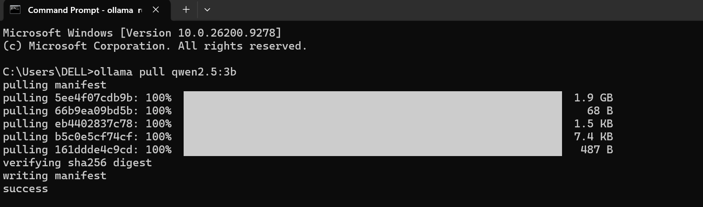
- Screenshot of the conversation & decoding with the Qwen 2.5 model
